
CHURCHFIELDS PRIMARY SCHOOL
School Street, Chesterton, Newcastle under Lyme, Staffs ST5 7HY
Tel: 01782 567430
Email: office@churchfields-chesterton.staffs.sch.uk
Headteacher: Mrs. D Beardsmore BA (Hons)
Deputy Headteacher: Mrs. C Pattison BA (Hons)

"Be the best you can be"
Part of the Collective Vision Multi-Academy Trust
1st December 2024
Dear parents and carers,
In a blink of an eye we are in December. This week children in Year 1 – 6 will be completing their Autumn term assessments. These help the class teachers know how much progress the children are making and which areas of the mathematics and English curriculum need to be revisited during the spring term. There is no need for your child to worry - all we ask is that they are the best that they can be. The result doesn’t matter as long as they have given them their best shot!
A reminder that we finish on Friday at 1:30pm so we can set up for the Christmas fair. Thank you for all your bottle donations – as always you are incredibly generous.
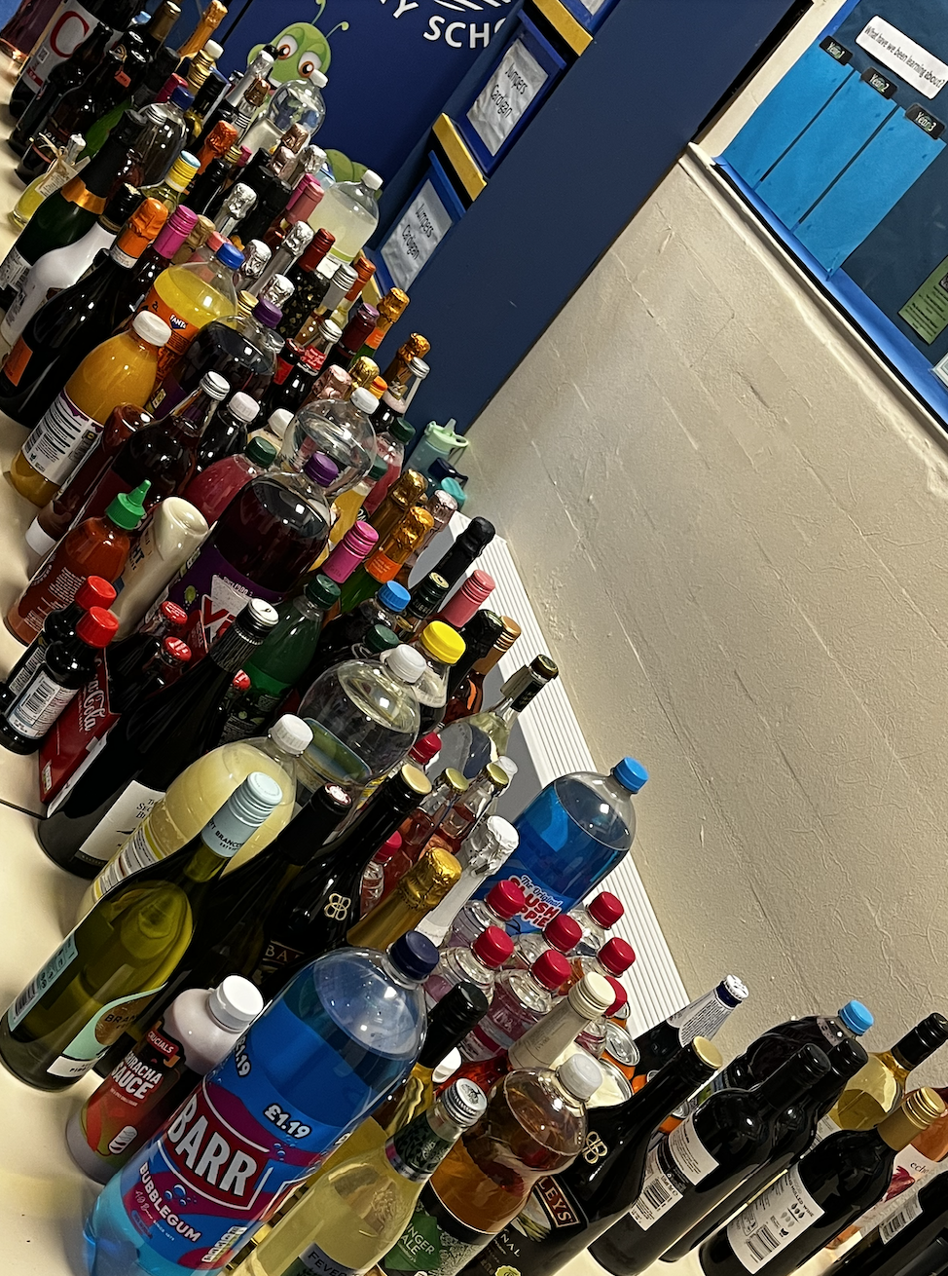

Last week we had a competition for Name the Elf IN YEAR 1 and 2 ONLY. Thank you to everyone in KS1 who entered and the winners were Holly-Ann Woodward and Isla Tainton-Dutton.
KS2 staff felt that they wanted to join in the fun, so Mr Skupham has organised a spot the elf competition as Thallan the elf has made itself invisible and hidden in a festive picture. It will be 20p a go to guess which square the elf is in. Winners to be announced on Friday.
A reminder it is Christmas dinner on Friday. As Christmas dinner takes a great deal of time to prepare, no other food is available from the school kitchen. As we start to get into the Christmas spirit THIS FRIDAY CHRISTMAS JUMPER/CLOTHES – no donations needed.
A reminder about raffle tickets:
Raffle tickets will also be available (again) from tomorrow £1 a strip. Prizes are:
- Middleport Pottery – Heritage Trail for 2
- Stoke City FC - 2x tickets Stoke City v Cardiff (14.12.24)
- The Lymedale Bar & Dine - £25 voucher
- Stoke Ski Centre - £20 voucher
- Balance & Bean - a half day school holiday camp
- Apedale Valley Light Railway - Family Pass
- New Vic Theatre - Two complimentary tickets
- Port Vale FC - 4x Match tickets
- Inflato - £10 voucher
- Team Sport Karting - One race session
- Chocolate Hamper
The raffle will be drawn at 4.30pm during the Christmas Fair. Winners will be listed and added to the school’s Facebook page. They will also be displayed in school. Any prized unclaimed after a 2-week period will be used at another school event.

Attendance News from Mr Skupham

On Friday 20th December during celebration assembly, I am very pleased to announce that a special draw will take place including all the children who have reached the attendance target of 96%. Hopefully, we are coming to the other side of all the bugs so we can all have a good run up to Christmas.

Carols
As part of the music Curriculum children in Year 1 – 6 will be performing calrols to the rest of the school. We will record each class singing one of these songs to send to parents on the Facebook page. A Microsoft form will be sent out to ensure that we have your permission to include your child’s image.

Important dates
Friday 6th December Children’s Christmas dinner
Friday 6th December – Christmas fair - School finishes at 1:30pm (as usual). The Christmas Fair is 3:30 – 5:00. There will be no after school club offered on this day
Monday 9th December Year 2 Festive Fun 2:00
Tuesday 10th December Reception (both classes) Festive Fun 2:00
Wednesday 11th December Year 1 Festive Fun 2:00
Thursday 12th December Year 3 Festive Fun 2:00
Friday 13th December Christmas Jumper day
Monday 16th December Christmas jumpers/clothes all week
Monday 16th December 2:15 Reception carols SN
Tuesday 17th December 2:15 Reception carols SL
Wednesday 18th December Nursery crafts and carols 2:00
Thursday 19th December 2:00 Choir concert
Friday 20th December - Break up for Christmas - There will be no after school club on this day

School Terms and Holiday Dates

Autumn Term 2024
Term Starts: Monday 4 November
Term ends: Friday 20 December
Holiday: Monday 23 December – Friday 3 January

Spring Term 2025
Term starts: Monday 6 January
Term ends: Friday 14 February
Holiday: Monday 17 February – Friday 21 February
Term Starts: Monday 24th February
Term ends: Thursday 10th April
Inset day: Friday 11 April
Holiday: Monday 14 April – Friday 25 April
Easter Sunday: Sunday 20 April

Summer Term 2025
Term starts: Monday 28 April
May Day: Monday 5 May
Term ends: Friday 23 May
Holiday: Monday 26 May – Friday 30 May
Inset day: Monday 2 June
Term starts: Tuesday 3 June
Term ends: Thursday 17 July
Inset day: Friday 18 July

Stars of the Week 29 11 24

Nursery Mrs Clowes Ilinca Stefan for always coming into nursery with a smile

Reception Mrs Locker Lewis Lilley for super progress with his behaviour

Reception Mrs Nixon Oliver Prince for a super week of learning

1B Sonny Ashmore-Finney for working hard to make his sentences excellent

1M Logan Jackson for always living up to our school motto

2B Harley Maddox for always being the best that he can be

2M Daisy-Mae Dale for fantastic independent writing that was a pleasure to read

3R Nova Rae Roberts for always working to her full potential

3W Michelle Obioha for creating a beautiful story in her independent writing

4M Phoebe Knipe for always being the best she can be

4SP Parker Smith for a fantastic week of learning

5K Lola Brennan for fantastic resilience in her learning this week

5L Rex Gater for a consistent effort with his work

6C Liam Daley for being an exceptional student and demonstrating the school values

6S Tjay Riley for being an outstanding student and a pleasure to teach

PE Stars

EYFS
Isabelle Sproston for showing great effort with her PE skills

KS1
Mackenzie Urquhart for super resilience using the gymnastics wall frame

LKS2
Simona Rumenova for super presentation when performing gymnastic actions

UKS2
Gracie Weaver for creativity when linking actions in a group sequence

Head Teacher’s Stars

NURSERY Maya Perickathara for always asking lots of questions and being a lovely member of the class

RECEPTION Evelina Tihon for a super attitude to her learning

KS1 Mackenzie Urquhart for super reading using his phonics

LKS2 Jess Jarvie for always being the very best that she can be

UKS2 Bertie Pattison for showing the school values and being a delightful student who always thinks of
others

Attendance
Attendance best class this week: 6C = 99%
Well done to: 2B, 4S and 5L who are above 96%
Whole school attendance for the week is 92%

Team of the Week Team of the Term, so far
R 2,325 R 19,500
Y 2,294 Y 19,521
G 1,925 G 19,671
B 2,088 B 19,568

Any general queries or if you are unsure who to contact – office@cfp.school or headteacher@cfp.school
Thank you for your continued support,
Diane Beardsmore
Headteacher

