
Our School
Reading Ambassadors

Our school reading ambassadors play a vital role in promoting reading across the school. They are involved with a range of different activities:
- reading and reviewing books
- planning and delivering reading assemblies
- updating our interactive reading display board
- fundraising for more reading material
- promoting reading challenges across all key stages
The reading ambassadors meet weekly at lunchtime with Mrs Mawdsley to discuss and share ideas.

Josie – Year 5
Favourite author: David Walliams

Ruby – Year 5
Favourite author: David Walliams
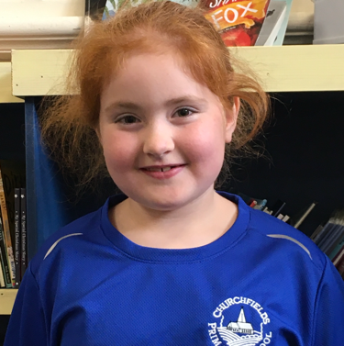
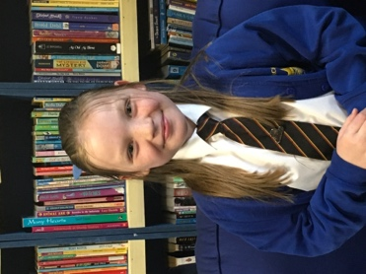

Darcie – Year 5
Favourite author: J K Rowling
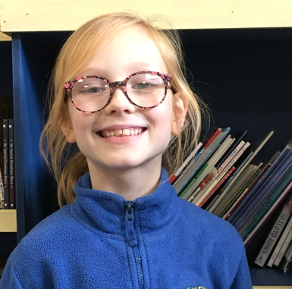
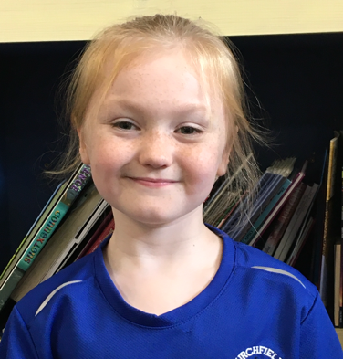

Penny – Year 5
Favourite author: Tom Fletcher

Ivy – Year 4
Favourite author: J K Rowling
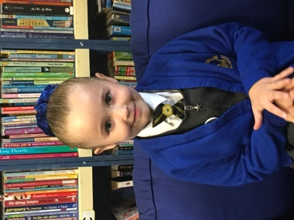
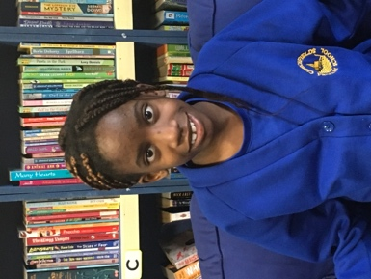

Mariette – Year 6
Favourite author: Roald Dahl

Nevaeh – Year 4
Favourite author: David walliams

Charlotte – Year 4
Favourite author: Ben Miller
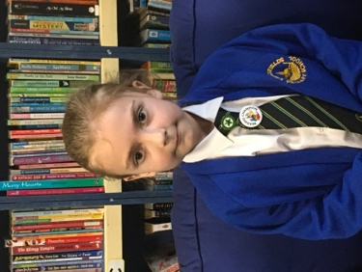
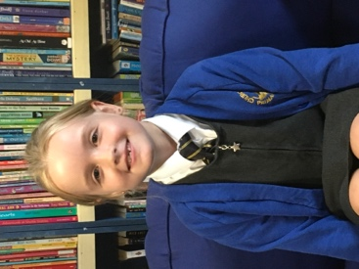

Julia – Year 4
Favourite author: J K rowling
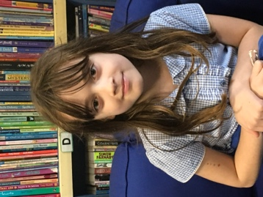

Chloe – Year 4
Favourite author: Ben Miller
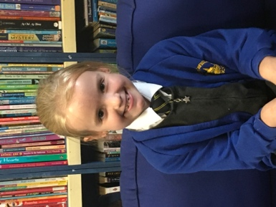

Josie – Year 4
Favourite author: Roald Dahl
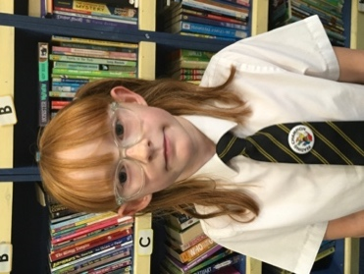
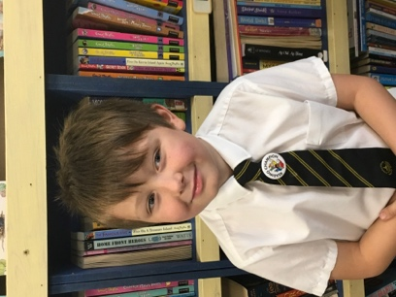

Arlo – Year 4
Favourite author: Ben Miller

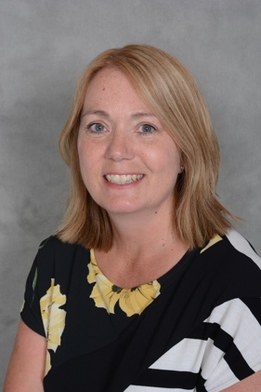
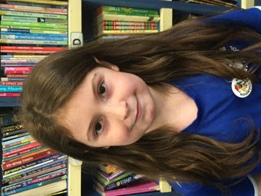

Ella-Rose – Year 6
Favourite author: J K Rowling

Mrs Mawdsley
Favourite children’s author: Ben Miller

