English Intent
English is a vital skill which unlocks children’s learning. It provides the children with the crucial knowledge, skills and understanding to make sense of their learning. It is our intent to develop children who:
- are able to communicate clearly in both written and spoken form for a range of different purposes and contexts
- read fluently for pleasure and to inform their learning.
We will expose our children to a wide range of vocabulary so that they able to develop their spoken and written language and communication.
We want our children to be enthusiastic writers. We will do this by giving the children the crucial knowledge they need so they can write confidently with accuracy and for a range of different purposes. This crucial knowledge has been selected to allow the children to be able to build and recap on essential learning from our EYFS all the way up to KS2.
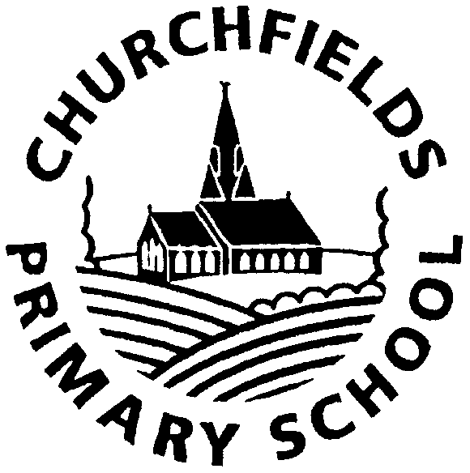
 | Autumn Term  Crucial Knowledge Writing | Spring Term  Crucial Knowledge  Writing | Summer Term  Crucial Knowledge  Writing
Nursery  EYFS | Mark making | Mark making  Forming letters of name  Letter formation | Mark making  Letter formation  Letter formation linked to phonic sounds  Name writing  Capital letter  CVC words
Reception  EYFS | Form lower case and capital letters correctly.  Write own name  Autumn 2 WORD-focus. Grouping letters to make a word. | Form lower case and capital letters correctly.  Finger spaces  Word  Phrase  Full stop | Form lower case and capital letters correctly.  Finger spaces  Word  Phrase  Full stop  Sentence
We want our children to be passionate about reading. We want them to read for pleasure and make choices about their own reading, we will do this by exposing them to high quality texts in the classroom and through a range of reading opportunities

 | EYFS Nursery
 | Term 1 |  | Term 2 |  | Term 3
Crucial Knowledge Reading | Letter- has a name and a sound, Word-a group of letters, Rhyme-words have or end in the same sound, Title-leads the whole text, Author- a person who writes a book or text. Illustrator - a person who draws pictures for a book, magazine or advert Phonics-sounds of letters
Crucial Knowledge  Writing | Lower case letters – smaller in size  Capital letters – used at the beginning of my name
Text | 1: Owl Babies  2: Owl Babies  3: Leaf Man  4: Supertato  5: Supertato  6: Funny Bones  7: Funny Bones | 1: Bear Hunt  2: Bear Hunt  3: All Change  4: Stickman  5: Stickman  6: We are Going on an Elf Hunt  7: Christmas Story | 1: On The Journey Home from Grandpa’s  2: Up, Up, Up  3: We All go travelling By.  4: Magic Train Ride.  5: The Smartest Giant in Town  6: The Smartest Giant in Town | 1.The shopping Basket.  2: Mr Wolf’s Pancakes  3: The Hungry Caterpillar  4: The Hungry Caterpillar.  5: Percy the Park Keeper Story  6: The Growing Story  7: We are Going on and Egg Hunt | 1: Jack and the Beanstalk  2: Percy The Park keeper.  3: Minibeasts  4: Little Sunflower | 1: Ten Little Pirates  2: Commotion in the Ocean  3: Penguins make Bad Pirates  4: Pirates love Underpants  5: Captain Pike looks after the Baby.  6: The Night Time Pirates.  7: Pete the Cat and the Tresure Map.

 | EYFS Reception
 | Term 1 |  | Term 2 |  | Term 3
Crucial Knowledge Reading | Letter- has a name and a sound, Word-a group of letters, Diagraph-two letters that make a single sound, Split diagraph-a diagraph with a consonant in between, Trigraph- three letters that make a single sound. Rhyme-words have or end in the same sound, Vowel- a e I o u, Title-leads the whole text, Author- a person who writes a book or text and Illustrator  Phonics- How we learn to read.
Crucial Knowledge  Writing | Lower case letters – smaller in size  Capital letters – used at the beginning of my name  Finger Spaces – gaps used between groups of letters  Word – a group of letters that mean something  Phrase – a group of words that tells information  Full stop – a dot to show the end of a sentence  Sentence – starts with a capital letter and ends with a full stop, must make sense
Text | 1: Colour monster  2: Peace at last  3: Owl babies  4: 3 Little Pigs  5: Jack and the beanstalk  6: Farmer duck  7. Assess Jolly Phonics | 1.Little red hen 2.Gingerbread man  3.Billy goats gruff  4.A superhero like you  5.The jolly postman  6.The jolly Christmas postman  7.Stickman | 1.The Gruffalo’s child  2.Ridiculous  3.Dear zoo  4.Monkey Puzzle  5.Let’s go home little bear | 1. Seed to sunflower  2. The Hungry Caterpillar  3. The bad-tempered ladybird  4. The very busy spider  5. Tadpoles /Frogs/Frog cycle | 1.Mr Gumpy’s outing  2.Flat Stanley- 2 weeks  3.Hansel and Gretel  4.Red Riding Hood  5.Super Cat’s Road Safety Story | 1.Lighthouse keeper’s lunch 2 weeks  2. What the ladybird heard at the seaside.  2 weeks  3. The snail and the whale  2 weeks

